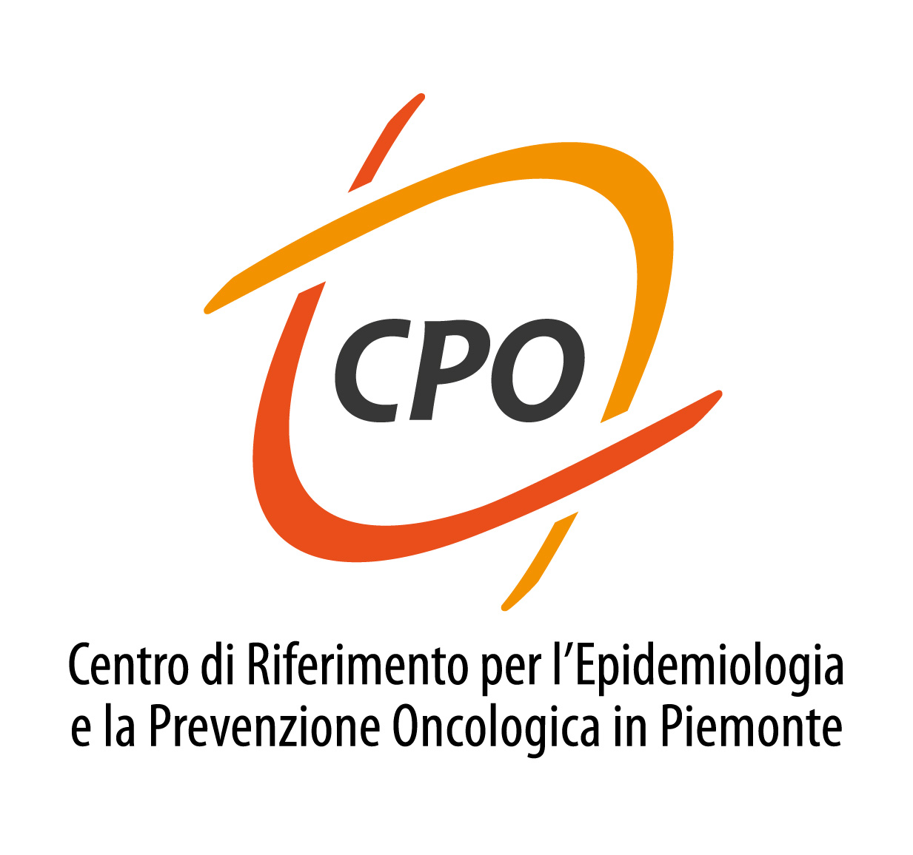



Unit of Cancer Epidemiology - CPO Piemonte

Pamela Surkan

Social Epidemiologist and Associate Professor
in the Social and Behavioral Interventions Program,
Department of International Health,
Johns Hopkins Bloomberg School of Public Health

Seminar

Precursors and consequences of mental health problems: the influence of familial relationships across generations

Family relationships are critical for child development and wellbeing. At the same time, these relationships, such as between parents and their children, have reciprocal influences on health. Research on the role of the family in shaping health outcomes will be presented, using examples from inter-generational studies. These studies will highlight ways in which maternal mental health can impact early child development as well as how child health status may influence maternal mental health. Finally, research in young adults will be used to illustrate that familial relationships may be important for substance use behavior. This research suggests that collateral health effects exist between family members and that the integration of the family in social and behavioral health initiatives may be warranted

Monday 17th July 2017 – h 14

Library of the Unit of Cancer Epidemiology - COES

