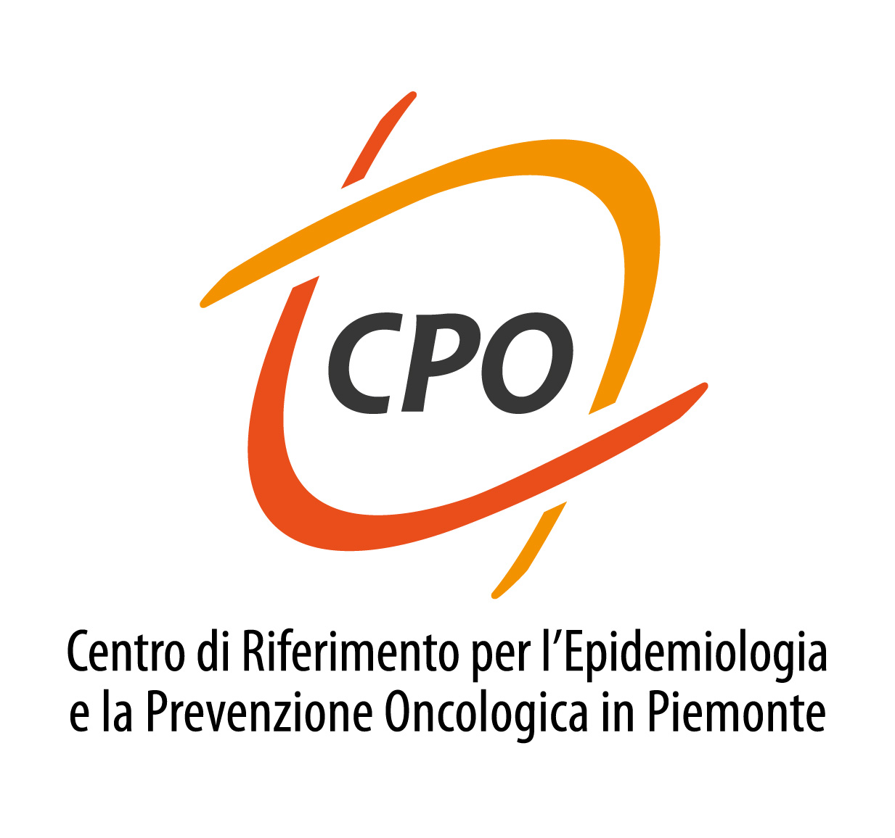


Unit of Cancer Epidemiology - CPO Piemonte

John Dockerty

Associate Professor, Epidemiology
Department of Preventive and Social Medicine
Dunedine School of Medicine, University of Otag, NZ

Seminar

The social, financial and psychological effects of childhood cancer on families, with an exploration of questions related to health care systems and of potential disparities in risks or outcomes.

Monday 13th November 2017 – h 14.45 – 15.30

CERMS Room

